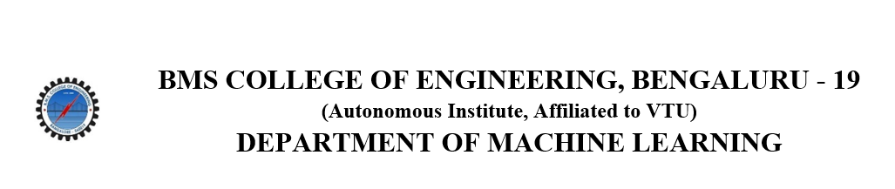
ACTIVITY REPORT
ON
Clock of Confusion
- Name of the Club: BMSCE ACM STUDENT CHAPTER
- Name of the Activity: Clock of Confusion
- Objectives: The BMSCE ACM Student Chapter in collaboration with BMSCE IEEE Student Branch organized a fun event named “Clock of Confusion”. This event aimed to foster teamwork, bring out creativity among participants.
- Date, Time Venue of the Activity:
EVENT | Clock of Confusion
DATE/DAY | 15th November 2024, Friday
TIME | 2:00 pm to 4:00 pm
VENUE | PJ Block, 5th floor, classroom 504 and 505
- Name and details of collaborating agency (if it is collaborative/joint activity): BMSCE IEEE Student Branch
- Brief summary of the Event:
The "Clock of Confusion" event, organized by the BMSCE ACM Student Chapter in collaboration with BMSCE IEEE , was a fun and challenging event held on November 15th , 2024. It consisted of different games, each designed to test participants' memory, riddle solving skills, and teamwork.
The event featured a series of engaging games designed to test participants' critical thinking, teamwork, and problem-solving abilities. In the Puzzle Game, teams were given a scrambled puzzle to solve with a reference image, and the fastest team to complete it earned the most points. The Card Game involved a scrambled deck of cards numbered 1 to 10, where teams had to arrange them in ascending order in the shortest time, starting over if they picked the wrong card. The Memory Game required teams to observe a table of objects for one minute and then answer questions based on their memory, with the highest-scoring team winning. In the Trading Game, teams were given random items and had to trade with others to accumulate the most valuable combination, testing their negotiation and decision-making skills.
The Mystery Box Conundrum involved opening boxes containing clues or challenges, where teams had to decide strategically when to open them and manage their points. The team with the highest score at the end of all rounds was declared the winner, emphasizing the importance of strategy, teamwork, and quick decision-making throughout the event.
The event encouraged participants to think critically, work together effectively, and enjoy the entertaining activities. The team with the highest score at the end of all three rounds was declared the winner.

- Outcomes: "Clock of Confusion" provided an excellent opportunity for participants to solve riddles in a new way , teamwork, and creative thinking in a supportive and engaging environment. The varied rounds ensured that each team member could contribute their strengths, promoting a collaborative spirit among participants.
- Number of participants:
Number of Teams | Number of Participants
23 | 46

- Photographs of the event: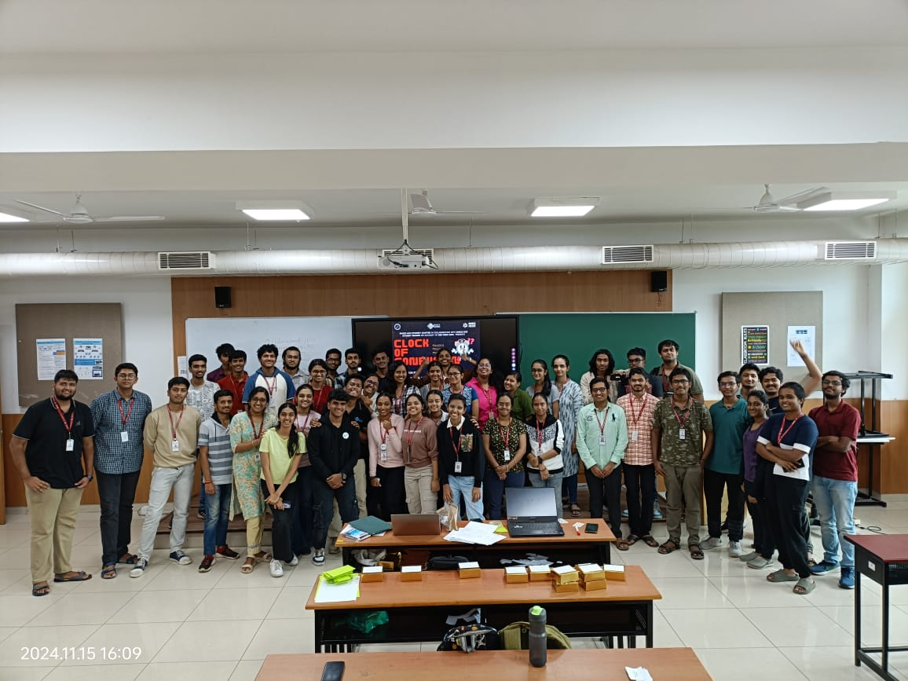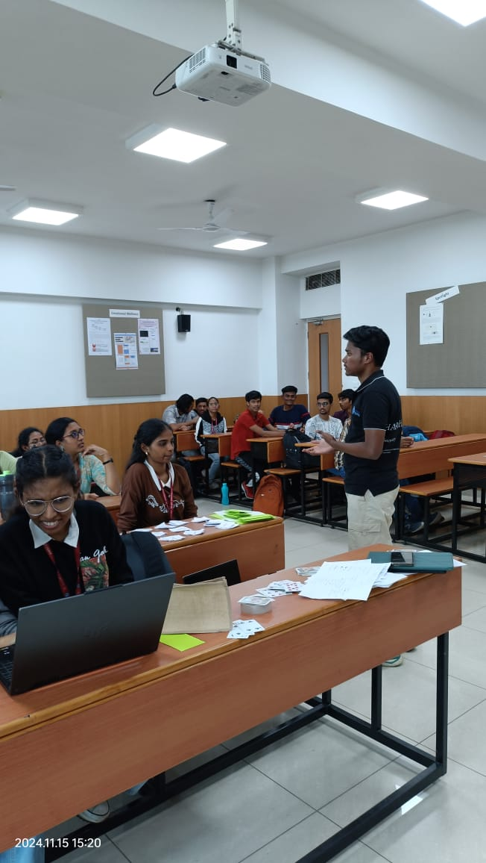

- Supporting Documents:
a. Circulars/Brochures:

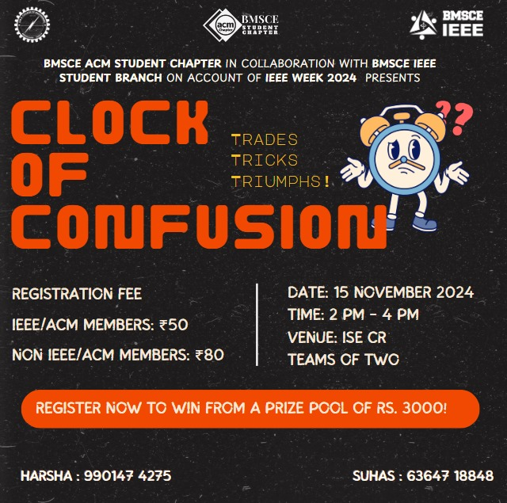
b. Certificates:

